**BANK LOAN REPORT QUERY DOCUMENT**

****(PostgreSQL)

**KPI`s**

Total Loan Application

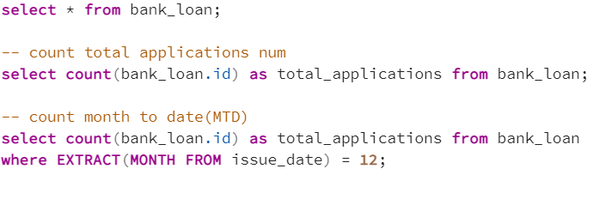

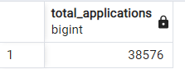

MTD Loan Application

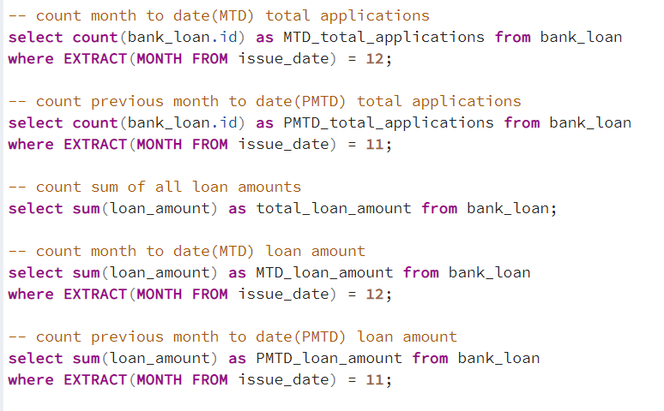

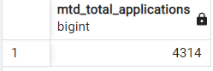

PMTD Loan Application



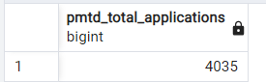

Total Funded Amount

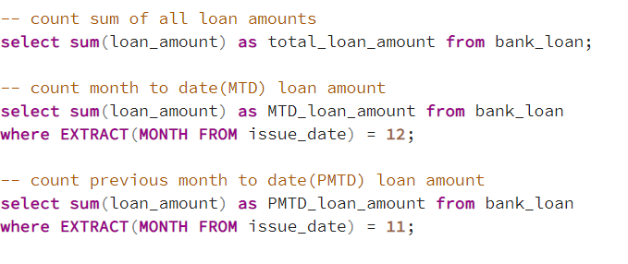

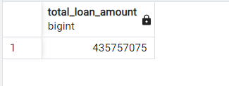

MTD Total Funded Amount



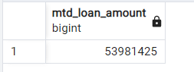

PMTD Total Funded Amount



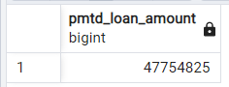

Total Amount Received



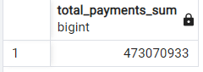

MTD Total Amount Received

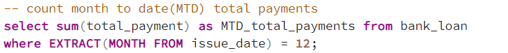

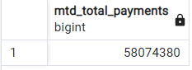

PMTD Total Amount Received

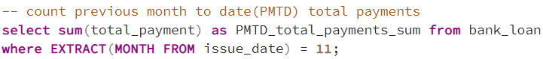

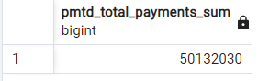

Average Interest Rate



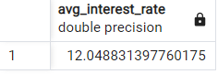

MTD Average Interest Rate

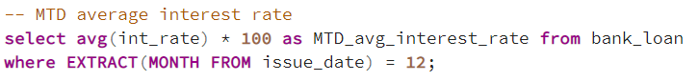

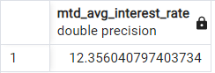

PMTD Average Interest Rate

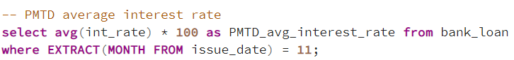

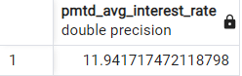

Average Debt-to-Income Ratio (DTI)

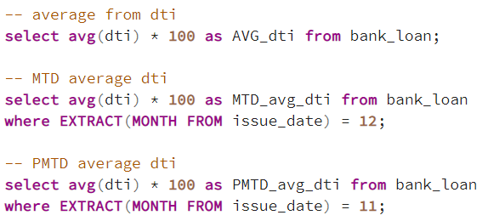

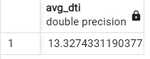

MTD Average Debt-to-Income Ratio



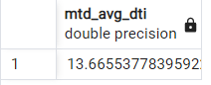

PMTD Average Debt-to-Income Ratio



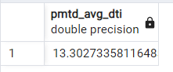

Amount of good loan applications

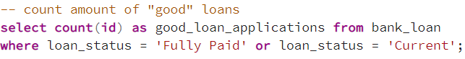

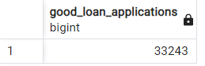

Percentage of good loan applications

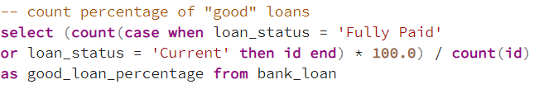

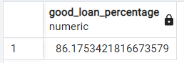

Payment funded to good loan

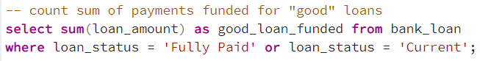

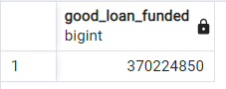

Payment from good loan received

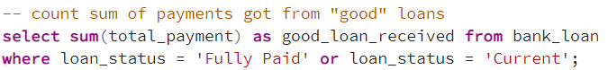

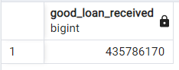

Amount of bad loan applications

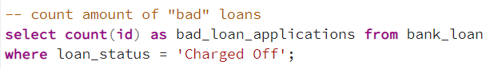

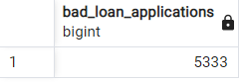

Percentage of bad loan applications

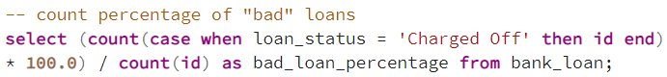

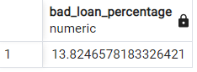

Payment funded to bad loan

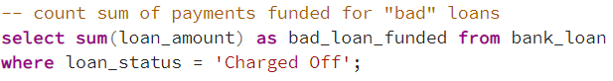

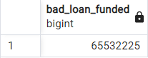

Payment from bad loan received

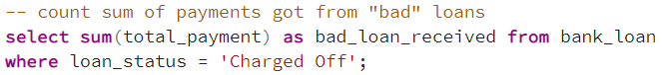

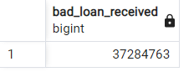

Loan Status

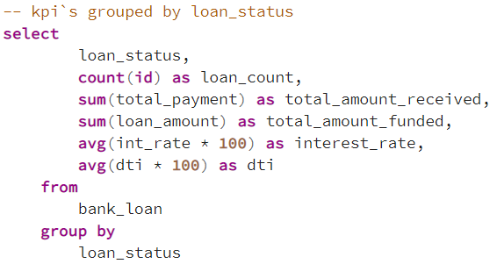

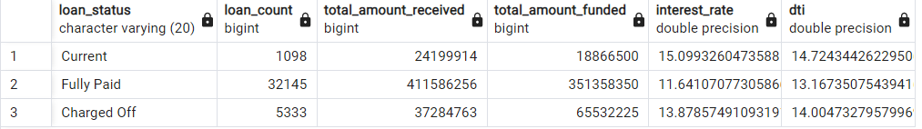

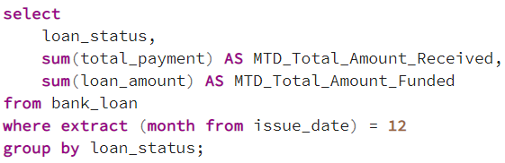

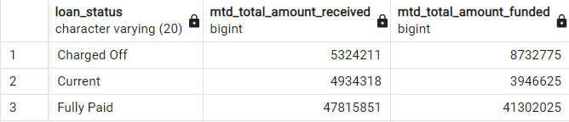

Month grouping

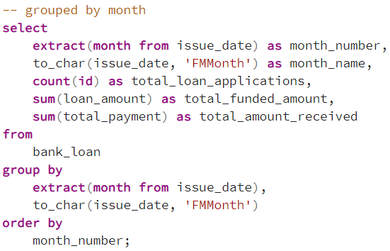

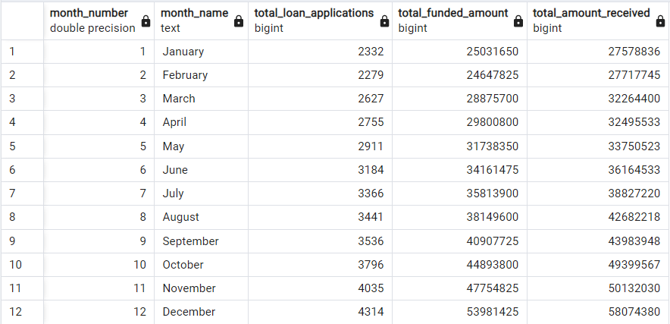

State grouping

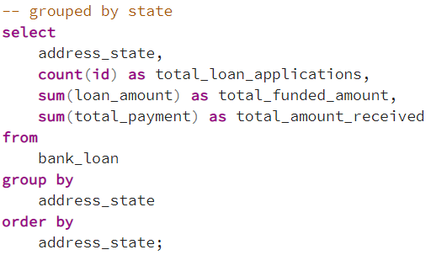

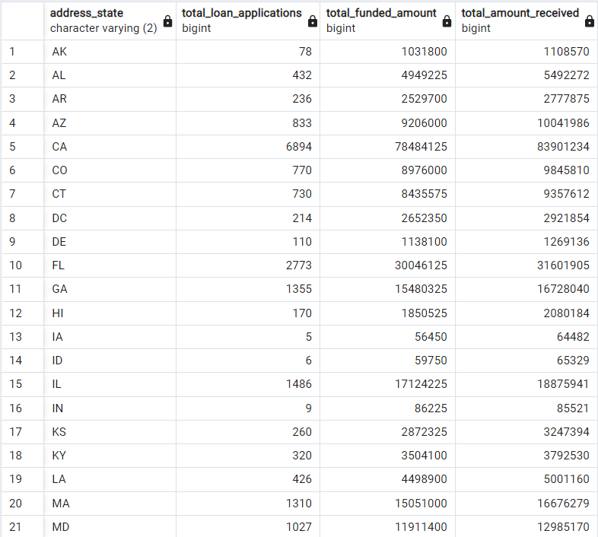

Term grouping

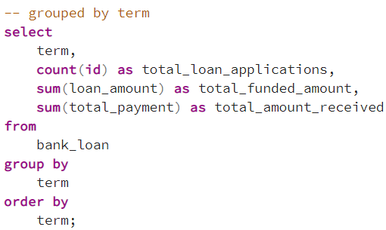

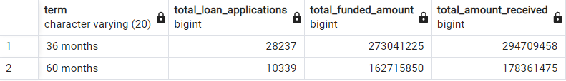

Employee length grouping

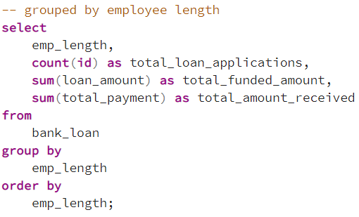

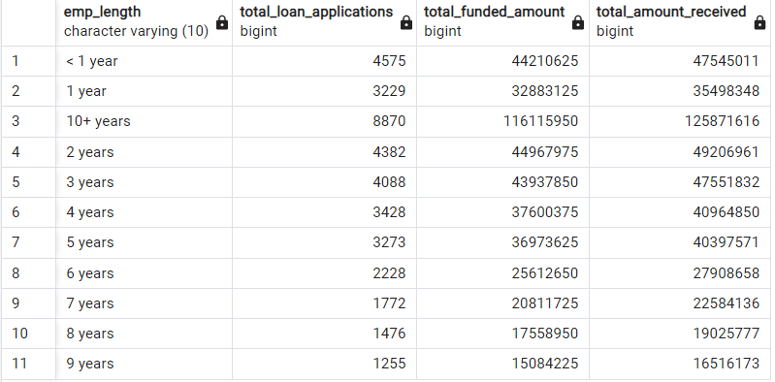

Purpose grouping

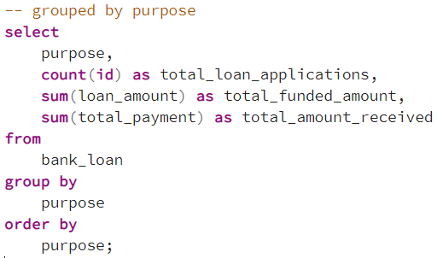

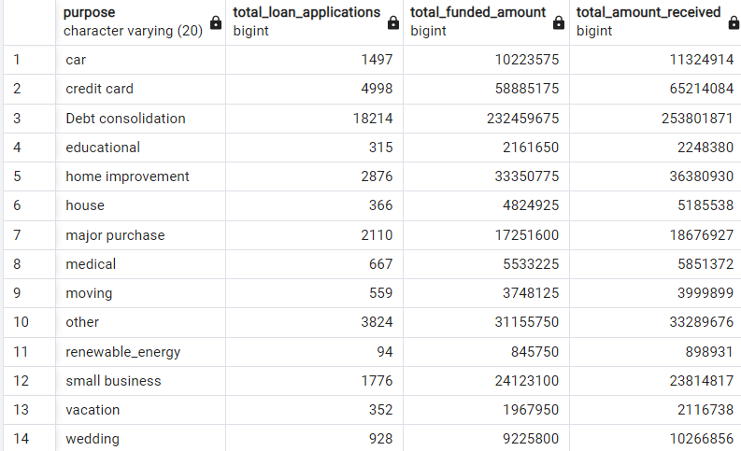

Home ownership grouping

